**Project Name: Amazon**

**Student Name: Shaikh Gulam Gaus**

**Edureka presents**

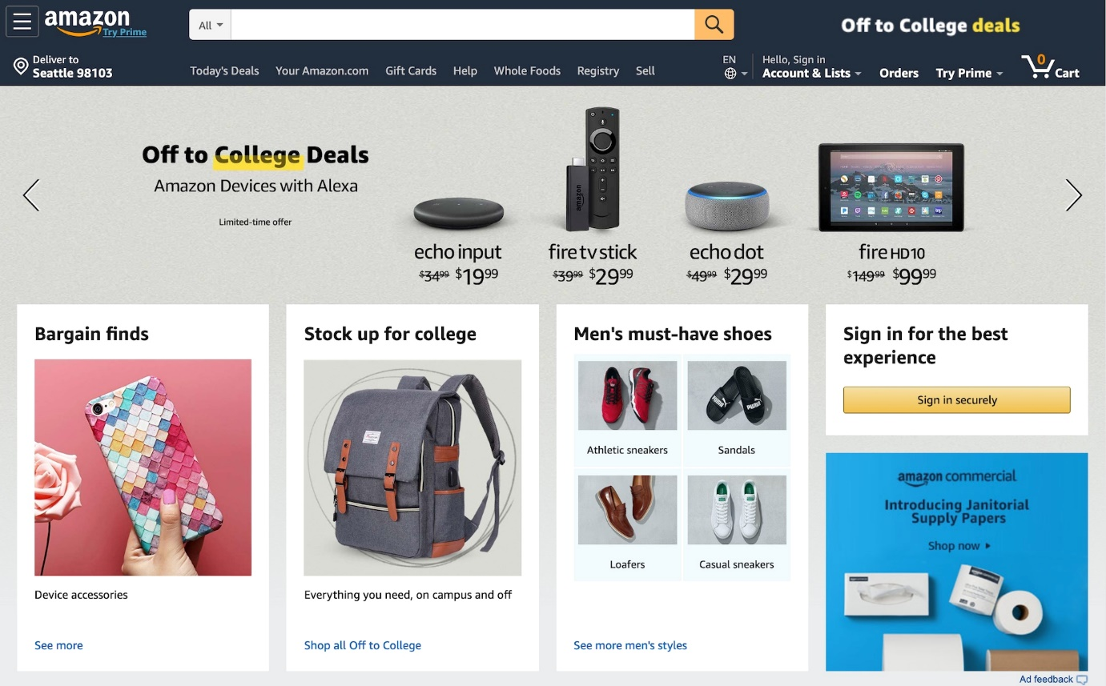

**Overview:**

**Amazon.com is a vast**[**Internet**](https://www.britannica.com/technology/Internet)**-based**[**enterprise**](https://www.britannica.com/topic/business-organization)**that sells books, music, movies, housewares, electronics, toys, and many other goods, either directly or as the middleman between other retailers and Amazon.com’s millions of customers.**

**Goals:**

**The Home Page**

**The Checkout Page**

**The Login Page**

**Username on Checkout Page**

**The Payment Page**

**The Orders History Page**

**History:**

**Amazon started off as an online bookstore selling books, primarily competing with local booksellers and Barnes & Noble. It IPOs in 1997. Amazon starts to expand its services beyond books. It also starts offering convenience services, such as Free Super Savers Shipping.**

**Technologies Used in Amazon:**

**Front-End:**

**HTML**

**CSS**

**REACT**

**Back-End:**

**NODEJS**

**Database:**

FIREBASE

**Code Compiler:**

**VISUAL STUDIO CODE**